**CHANDRIKA WOMEN AND YOUTH FOUNDATION**



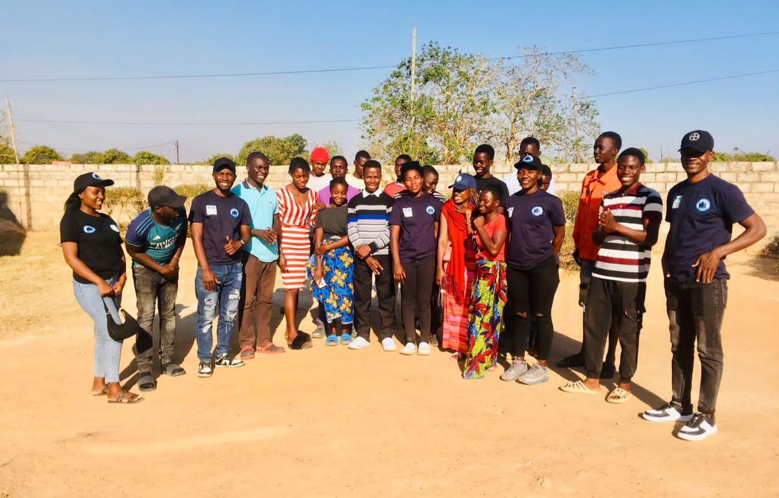

**REPORT ON BUNTUNGWA YOUTH FRIENDLY CORNER CLIMATE CHANGE SENSITISATION ACTIVITY**

**Introduction**

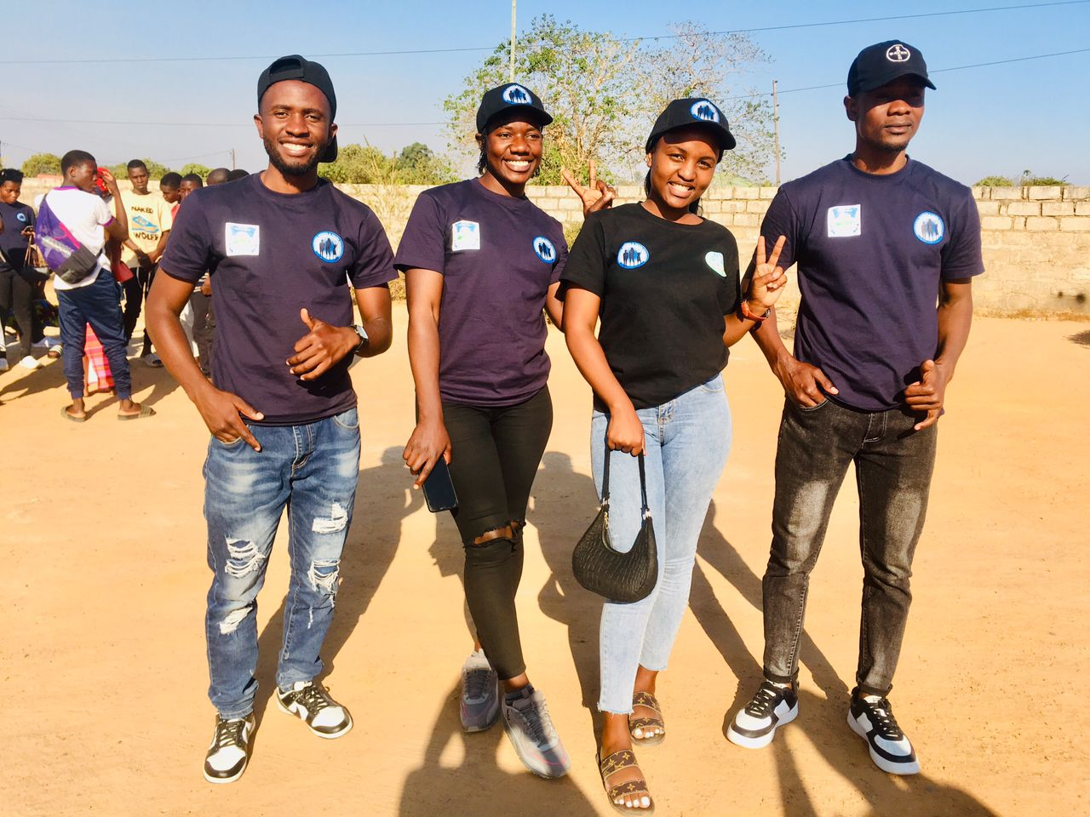This activity report is based on the Climate Change Sensitization Activity which was conducted on the 13th of September 2024. The sensitization activity was held at Buntungwa Youth Friendly Corner at Buntungwa Clinic and in attendance were a total of 23 youths broken down as follows: 15 Males and 8 Females.

***Youths from Chandrika WYF who conducted the sensitization on Climate Change***

**Activity Objective**

To empower youths with cardinal information related to Climate Change, for them to take action on environmental sustainability in their communities.

**Activities during the Sensitization**

The program began at 2 PM and welcoming remarks were given by the Amapange Yansaka Chairperson, Ms Chishala Yamuntu. Thereafter, the floor was opened for introductions, allowing participants to get to know each other better.

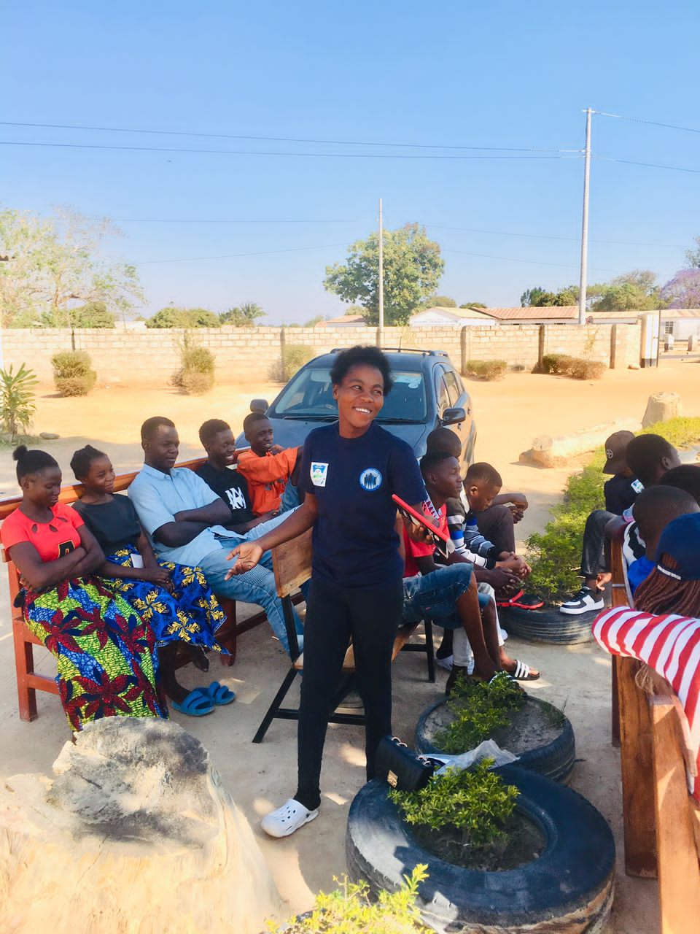An overview of Chandrika Women and Youth Foundation was given educating those present on the organization’s purpose, goals, target audience and the activities that are being implemented by the organization i.e. The Theory of Change Project.

***One of the trained Climate Change Champions sensitizing her fellow youths on Climate Change***

**Definition of Climate Change**

Climate Change “Ukuchinga Kwa Michele” refers to long term shifts in temperatures and weather patterns i.e. conditions becoming wetter, warmer or dryer than usual.

**What Causes Climate Change?**

* Deforestation – cutting down trees
* Bush fires – the burning of bushes
* Industrial activities – e.g. manufacturing of food and mining activities
* Cars – cars emit carbon monoxide resulting in pollution of the environment
* Excessive use of fertilizers – the soil becomes less fertile

**The Effects of Climate Change**

* Rising temperatures, changes in precipitation patterns, and sea level rise which lead to extreme weather events such as heat waves, droughts, and floods.
* Affects ocean currents, the water cycle, and biodiversity.
* Affects human health, agriculture, and economy.

**The Impacts of Climate Change**

* Displacement
* Temperature changes
* Displacement of people
* Change in precipitation (rain patterns)
* Disease burden
* Nutrition issues – stunting
* Loss of economic livelihood
* Gender and social related issues
* Underdevelopment
* Dependence syndrome

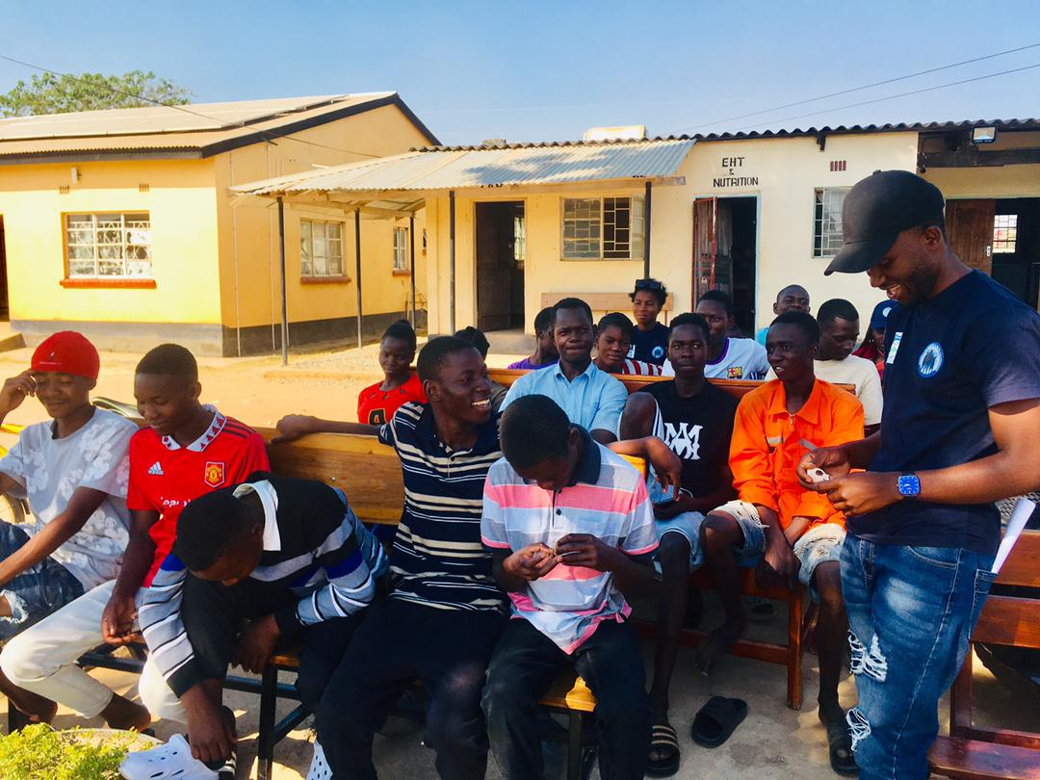**How Youths Can Fight Climate Change**

***The Youth Coordinator having a light moment with the youths during the meeting***

1. 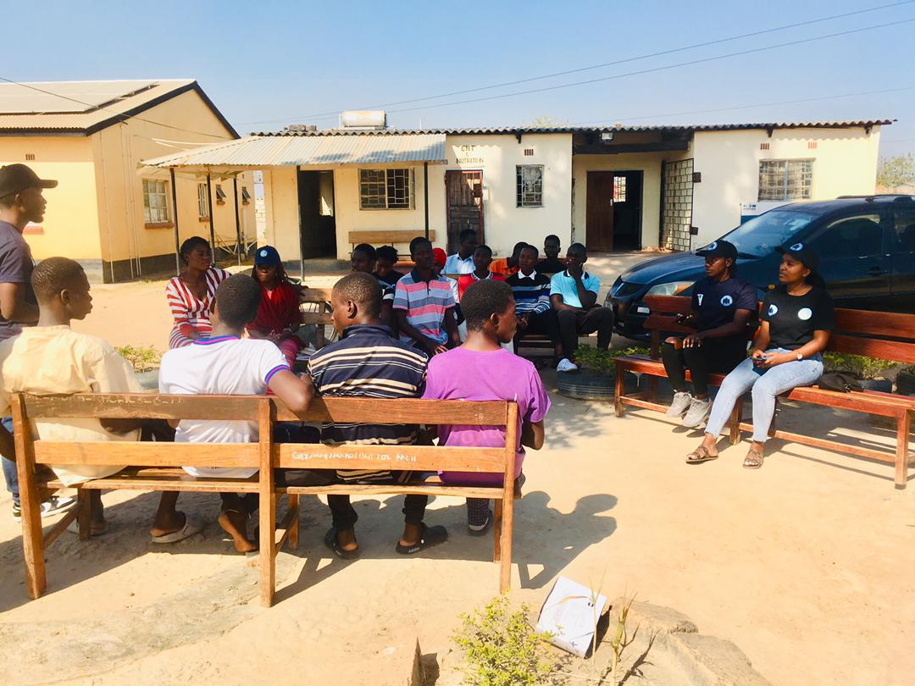Creating climate change clubs in schools and communities can help engage young people in climate change issues and education. Members of the club can participate in educational and awareness-raising activities such as seminars, workshops, field trips, and tree planting exercises.

***Youths during the Climate Change Sensitization***

1. Institutions can include climate change in their curriculum to provide an education that prepares youths to participate in sustainability activities. Topics such as greenhouse gas emissions, renewable energy, and climate adaptation strategies should be integrated into subjects such as science, social studies, and geography.
2. Social media can be used to disseminate messages and resources to people, providing an opportunity to educate, sensitize, and motivate them to participate in climate change activities.
3. Tree planting should be introduced in churches, schools, health centres etc. if even a small number of youths start actively making a change, more people from all walks of life will be inspired to become proactive.
4. Stop burning waste and indiscriminate throwing of garbage

**Conclusion**

As the team concluded the program they challenged the youths present to become Climate Change leaders advocating for sustainable practices, reducing their carbon footprint and inspiring others to do the same. As Chandrika WYF we look forward to witnessing the positive change that will come from this successful sensitization program.